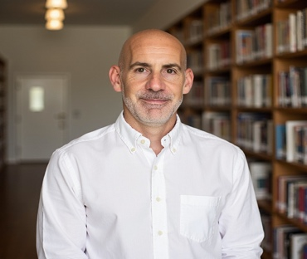
Scott Wells, CFA
Senior Financial Executive | Strategic Leadership | Value Creation
Los Angeles, CA | (480) 215-1025 | scottwellscfa@gmail.com | LinkedIn
"Boardroom brain. Operator hustle. Wall Street sharp. Scott Wells gets it done."
Scott Wells, CFA is the dealmaker with depth. A powerhouse of financial strategy, blending 20+ years of sharp corporate banking acumen with a C-suite lens for growth, structure, and transformation. From Fortune 500s to scrappy startups, he speaks the language of capital markets fluently which matters when he’s juggling decision making in treasury, investor relations, and high-stakes M&A.
Scott is not just a finance executive, he’s a builder. Whether it's a 90-day CFO blueprint, a market pitch to JPMorgan, or crafting financial models / CIMs, he moves fast, thinks big, and backs it up with precision.
Recognized for driving transformative growth and delivering operational excellence, Scott has led cross-functional teams and initiatives across public and private companies, private equity-backed platforms, and financial institutions.
Currently as the owner and Managing Partner at G&O Consulting, Scott provides strategic capital advisory and fractional CFO services to middle market businesses. Additionally, Scott is a Managing Director with Minerva Valuations where he specializes in debt capital advisory, business valuations, and M&A.
Prior to G&O and Minerva, Scott served as Vice President of Finance at MDpanel (which acquired California Medical Evaluators (CME) where he was the CFO), a PE-backed healthcare services platform. At CME, Scott oversaw a $50 million P&L, drove 22.5% YoY EBITDA growth, and led initiatives that produced significant recurring savings, including system upgrades, vendor transitions, and the capture of over $2 million in Employee Retention Tax Credits. He played a pivotal role in the company’s successful sale to MDpanel, a strategic buyer backed by another PE firm and stayed on to assist with post-merger integration and the run financial operations and treasury units.
Scott’s earlier career includes leading the finance department at Imaging Endpoints, a privately-held iCRO where he led accounting, treasury, and facilitated a global banking expansion. Further on, Scott spent a 20 year career in corporate banking with roles at Bank of America, BBVA Compass and Wells Fargo, providing corporate debt and structured capital solutions. Scott started his career through a formal credit training program at Comerica Bank (recently acquired by Fifth-Third). His work consistently delivered cost efficiencies, improved cash flow visibility, and increased stakeholder returns.
Scott holds a Bachelor of Science in Finance from Miami University of Ohio and is a Chartered Financial Analyst (CFA) charterholder. He has also passed the FINRA Series 3 and SIE exams. He is active in the CFA Society of Los Angeles, Financial Executives Networking Group, and the Private Directors Association.

